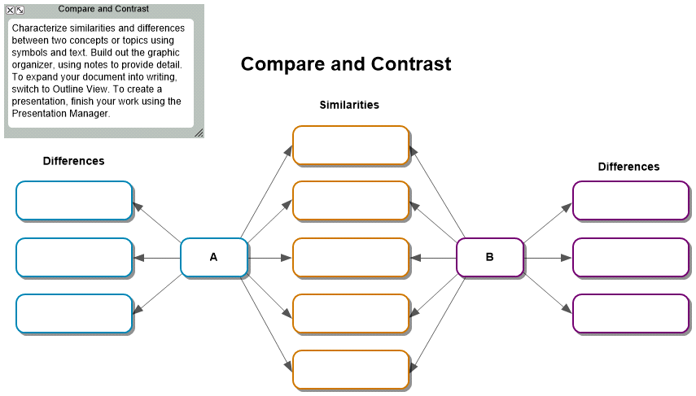

Compare and Contrast
Characterize similarities and differences between two concepts or topics using symbols and text. Build out the graphic organizer, using notes to provide detail. To expand your document into writing, switch to Outline View. To create a presentation, finish your work using the Presentation Manager.
I. Similarities
A.
B.
C.
D.
E.
II. A
A. Differences
B.
C.
D.
III. B
A. Differences
B.
C.
D.

